6.1 The Wave Nature of Light

Waves - wavelength, frequency, speed reflect, refract, interfere

Electromagnetic radiation vs sound waves no medium, constant velocity

c =  = 3.0p8 m/s

Spectrum lowest  = highest  = gamma rays < 1n11 (ish)

x-rays 1n11 m to 1n8 m (ish)

ultra-violet 1n8 to 4n7 m

visible 4n7 m to 7n7 m

infra-red 7n7 m to 1n4 m (ish)

microwaves 1n4 to 1n1 m (ish)

longest  = shortest  = radio >0.1 m

6.2 Quantized energy and Photons

Max Planck energy comes in tiny chunks called a “quantum”

E = h h = Planck’s Constant 6.63n34 Jsec

Photoelectric Effect (explained by Einstein, based on Planck)

* light lower than a specific frequency will not cause e- to be emitted
* light higher than that frequency will not cause more e- emission, it causes electrons to be emitted with greater kinetic energy
* more intense light causes more e- to be emitted

So, is light a wave or a particle?

6.3 Bohr’s Model of the Hydrogen Atom

Hydrogen is the simplest atom, so easiest to figure out

Continuous spectrum (incandescence)

Line Spectrum (electron transition)

Show EXAMPLES

Johann Balmer noticed the formula to describe the four visible lines of H spectrum followed the formula

$ν=C\left[\frac{1}{2^{2}}-\frac{1}{n^{2}}\right]$ where n = 3, 4, 5, and 6 and C = 3.29p15 s–1

So Bohr assigned electrons to orbits that each had energy of

$E_{n}= -R_{H}\left[\frac{1}{n^{2}}\right]$ where n = 1, 2, 3, 4…

and RH (Rydberg Constant) = 2.18n18 J

n is an integer, “principal quantum number”

There are other n’s in H but only 3→2, 4→2, 5→2 and 6→2 lead to visible

What does 5→1 lead to?

What does 5→4 lead to?

Graph on side of page 196 *corresponds to* electron energy levels in H atom, but is not a picture of the layers of electrons!

For H, an electron changing energy from initial (i) to final (f) can be described by:

E = Ef – Ei = h

which breaks the final - initial rule because it calculates the frequency of the photon based on the E of the e– but the e– never has a frequency in this case.

6.4 The Wave Behavior of Matter

a.k.a. The Headache!

The observed behavior of a wave through a slit & two slits (show pictures)

The observed behavior of a beam of electrons through a slit & two slits is the same

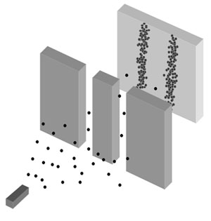 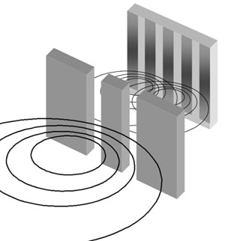

This is what **particles** do This is what **waves** do

(blacklightpower.com)

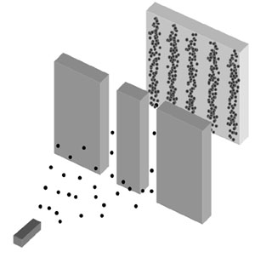 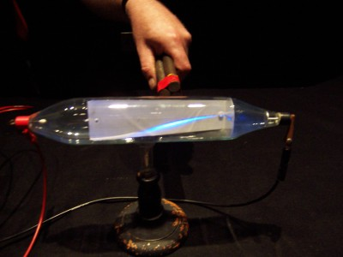

This is what **electrons**  do if you look for waves… and if you look for particles

Waves, or particles? It depends on how you look at them, literally.

Equations that describe particles (see Physics) describe electrons, so they must be particles.

Equations that describe waves (see Physics) describe electrons, so they must be waves.

As it turns out, *all* matter has both natures: $λ=\frac{h}{mv}$ De Broglie Equation

But the wavelength of visible objects is vanishingly small, and any slit that could make a baseball act as a wave is smaller than the diameter of a neutron, and bulk properties swamp our wave nature.

Heisenberg Uncertainty Principle (descriptive only)

6.5 Quantum Mechanics and Atomic Orbitals

Orbits NO

Probability Density YES

Region of 90% likelihood of finding a given electron is called an ORBITAL

Orbitals are mathematically described by wave mathematics.

Standing waves, constructive and destructive interference

2-dimensional = jump rope

3-dimensional = drum head

Extend all around the world → standing waves

Imagine a drum head without a rim, or an ocean with no shores

Ax3 + Bx2 + Cx + D = 0 What’s the shape? (See the spreadsheet)

Like A, B, C, D above, quantum numbers describe the 90% shape (orbital)(address) of a house where an electron can live. If an electron lives there, that’s how we identify it.

The Time Independent Schroedinger Equation for an electron:

{E}\psi(r) = - {\hbar^2 \over 2m} \nabla^2 \psi(r) + V(r) \psi(r)

has embedded within it four “Quantum Numbers” similar to ABCD:

n principal quantum number = 1, 2, 3, 4…

describes the overall *energy* level, and extent of the *physical layer*

l azimuthal (angular momentum) = 0, 1… n-1

describes the shape or orbital type

specifies the number of *nodes*

m magnetic (orientation) = -l, -l+1…l-1, l

s “spin” (not quite really) = ±

~~Two~~ Three Good Rules

* Pauli Exclusion Principal - no two electrons in an atom can have the same values for all four quantum numbers
* Hund’s Rule - electrons are teenagers. I mean, they exist in the lowest possible energy states
* Electrons like each other a little bit, but won’t share an orbital until they’re forced

|  |  |  |
| --- | --- | --- |
| l = 0  0 nodes | s-orbital | http://img.sparknotes.com/figures/0/083ee1e849c82204c3d7c342d336a448/sorbital.gif |
| l = 1  1 node | p-orbital | http://img.sparknotes.com/figures/5/5578bdf1aec90e46e14325a580fdbf6a/porbital.gif |
| l = 2  2 nodes | d-orbital | http://wikis.lawrence.edu/download/attachments/295337/FG06_023.gif |
| l = 3  3 nodes | f-orbital | http://sciencephoto.com/image/2201/large/A1520151-5f_electron_orbitals,_general_set-SPL.jpg |
| l = 4  4 nodes | “g-orbital” | OUCH!  Plus, seriously, what atom has electrons “living” here?  What atom *will*? |

So, what does this tell us?

Hydrogen (just **one electron**; quite simple)

n = ∞ E = 0 (no longer in an orbital)

n = 4 E = -82 kJ/mol ___ ___ ___ ___ ___ ___ ___ ___ ___

4s 4p 4d (& 4f)

n = 3 E = -146 kJ/mol ___ ___ ___ ___ ___ ___ ___ ___ ___

3s 3p 3d

n = 2 E = -328 kJ/mol ___ ___ ___ ___

2s 2p

n = 1 E = -1312 kJ/mol ___

1s

But all other atoms have **multiple electrons**

(no longer drawn to “scale”)

___ ___ ___

6p

___ ___ ___ ___ ___

5d

___ ___ ___ ___ ___ ___ ___

4f

n = 6 ___

6s

___ ___ ___

5p

___ ___ ___ ___ ___

4d

n = 5 ___

5s

___ ___ ___

4p

___ ___ ___ ___ ___

3d

n = 4 ___

4s

___ ___ ___

3p

n = 3 ___

3s

___ ___ ___

2p

n = 2 ___

2s

n = 1 ___

1s

OUCH!

OK, How about…

Here’s a list of orbitals in each energy level:

1s

2s 2p

3s 3p 3d

4s 4p 4d 4f

5s 5p 5d 5f

6s 6p 6d 6f 6g

7s 7p 7d 7f 7g 7h

Here’s the order to fill them:

1s

2s 2p

3s 3p 3d

4s 4p 4d 4f

5s 5p 5d 5f

6s 6p 6d 6f 6g

7s 7p 7d 7f 7g 7h

And here’s an even better way!

|  |  |  |  |  |  |  |  |  |  |  |  |  |  |  |  |  |  |  |  |
| --- | --- | --- | --- | --- | --- | --- | --- | --- | --- | --- | --- | --- | --- | --- | --- | --- | --- | --- | --- |
|  |  |  |  |  |  |  |  |  |  |  |  |  |  |  |  |  |  |  |  |
| **1** |  |  |  |  |  |  |  |  |  |  |  |  |  |  |  |  |  |  |  |
| **2** |  |  |  |  |  |  |  |  |  |  |  |  |  |  |  |  |  |  |  |
| **3** |  |  |  |  |  |  |  |  |  |  |  |  |  |  |  |  |  |  |  |
| **4** | ns | |  |  |  |  |  |  |  |  |  |  | np | | | | | |  |
| **5** |  |  | (n-1)d |  |  |  |  |  |  |  |  |  |  |  |  |  |  |  |  |
| **6** |  |  |  |  |  |  |  |  |  |  |  |  |  |  |  |  |  |  |  |
| **7** |  |  |  |  |  |  |  |  |  |  |  |  |  |  |  |  |  |  |  |
|  |  |  |  |  |  |  |  |  |  |  |  |  |  |  |  |  |  |  |  |
|  |  |  | **6** | (n-2)f | | | | | | | | | | | | | | |  |
|  |  |  | **7** |  |  |  |  |  |  |  |  |  |  |  |  |  |  |  |  |
|  |  |  |  |  |  |  |  |  |  |  |  |  |  |  |  |  |  |  |  |